**Unit : 4**

**Q1: What is the difference between Multiple Access & Multiplexing?**

Answer :

### **Difference Between Multiple Access and Multiplexing:**

**1. Multiple Access (MA):**

* **Definition**: Multiple Access ka matlab hota hai ki multiple users ek hi communication channel ko ek saath share karte hain. Isme har user ke liye alag technique use hoti hai channel allocate karne ke liye.
* **Purpose**: Ye ensure karta hai ki multiple users ek hi resource ko efficiently use kar sakein.
* **Example**:
  + **Mobile Networks**: Ek mobile tower se ek hi frequency par multiple users ki baat karna.
  + Techniques: TDMA, FDMA, CDMA.
* **Real-Life Example**:  
  Socho ek classroom hai, aur teacher ne students ko alag-alag slots diye hain questions puchhne ke liye. Har student apna slot use karta hai without interfering.

**2. Multiplexing (MUX):**

* **Definition**: Multiplexing ka matlab hota hai ki multiple signals ko ek single channel par combine karna.
* **Purpose**: Iska aim hota hai bandwidth efficiently use karna.
* **Example**:
  + **TV Channels**: Multiple TV channels ek hi cable line me combine kiye jaate hain aur fir users tak bheje jaate hain.
  + Techniques: TDM, FDM, WDM.
* **Real-Life Example**:  
  Socho ek railway track hai, aur us par multiple trains chal rahi hain. Alag-alag time ya alag tracks ke basis par trains manage ki ja rahi hain.

|  |
| --- |
| **Key Differences:** |
| |  |  |  |  |  |  |  |  |  |  |  |  |  |  |  |  | | --- | --- | --- | --- | --- | --- | --- | --- | --- | --- | --- | --- | --- | --- | --- | --- | | |  |  |  | | --- | --- | --- | | Aspect | Multiple Access | Multiplexing | | Purpose | Multiple users ko ek resource share karwana | Multiple signals ko ek channel me combine karna | | Focus | Users | Signals | | Techniques | TDMA, FDMA, CDMA | TDM, FDM, WDM | | Real-World Use | Mobile communication | Cable TV transmission | | |

**Block Diagram (for better understanding):**

**Multiple Access**

User1 → Channel 1

User2 → Channel 2

User3 → Channel 3

**Multiplexing**

Signal1 + Signal2 + Signal3 → Multiplexer → Single Output Channel

**Q2. Define the term ALOHA. Explain Pure and Slotted ALOHA. What is the Multiple Access for Radio Packet System?**

**Answer :**

### ALOHA:

* **Definition**: ALOHA ek random access protocol hai jo wireless communication me use hota hai. Iska main kaam ye hai ki multiple users ko ek shared communication channel use karne ka method provide karna.
* **Origin**: ALOHA system sabse pehle 1970s me Hawaii University ne develop kiya tha for satellite communication.

### Types of ALOHA:

#### **Pure ALOHA**:

* **Working**:
  + Users apne data packets kisi bhi random time par bhejte hain.
  + Agar do users ka data ek hi time par bheja gaya, to collision hoga (data lost).
  + Data ko resend karna padta hai, lekin resend time random hota hai to avoid repeated collision.
* **Efficiency**:
  + Maximum efficiency **18.4%** hoti hai.
* **Example**:  
  Socho ki ek radio station pe log bina kisi time slot ke apne messages bhej rahe hain. Agar do log ek saath bolte hain, to dono ka message miss ho jaata hai.

#### 2. **Slotted ALOHA**:

* **Working**:
  + Time ko fixed slots me divide kiya jaata hai.
  + Users apna data sirf ek specific time slot ke starting me hi bhej sakte hain.
  + Agar collision hota hai, to resend karte hain lekin agle random slot me.
* **Efficiency**:
  + Maximum efficiency **36.8%** hoti hai, kyunki collisions kam hote hain.
* **Example**:  
  Socho ek classroom me students sirf apni turn par questions puchhte hain (fixed slots), is wajah se zyada clear communication hoti hai.

### **Multiple Access for Radio Packet System**:

* Radio Packet Systems me **TDMA (Time Division Multiple Access)** ya **CDMA (Code Division Multiple Access)** ka use hota hai.
* **TDMA**:
  + Har user ko ek specific time slot diya jaata hai data send karne ke liye.
* **CDMA**:
  + Har user ko ek unique code assign kiya jaata hai, jisse multiple users ek hi frequency channel share karte hain bina interference ke.

**Q3. Explain briefly the Packet and Pooling Reservation Based Multiple Access Schemes.**

**Answer :**

**Packet Reservation Multiple Access (PRMA):**

**Definition:**

PRMA ek hybrid scheme hai jo voice aur data transmission ke liye use hoti hai. Isme time slots ko dynamically reserve kiya jaata hai data packets ke liye, taki bandwidth efficiently use ho.

**Working:**

1. **Time Division**:
   * Channel ko multiple **time slots** me divide kiya jaata hai (similar to TDMA).
2. **Reservation**:
   * Voice users time slots ko **reserve** karte hain jab unhe consistent transmission chahiye hoti hai.
   * Data packets randomly bheje jaate hain (no reservation required).
3. **Collision Handling**:
   * Agar do users ek hi slot ke liye request karte hain, to **collision detect** hoti hai aur retransmission karna padta hai.

**Example:**

Socho ek bus reservation system hai jisme seats (time slots) ko dynamically book kiya jaata hai. Voice users (priority passengers) ko seats reserve karne ka option diya jaata hai, jabki casual passengers randomly board karte hain.

**Pooling Reservation Multiple Access (PRMA with Polling):**

**Definition:**

Polling Reservation Multiple Access ek enhanced version hai, jisme **polling** ka use hota hai to decide kis user ko channel access milega. Ye system zyada orderly hota hai aur idle slots avoid karta hai.

**Working:**

1. **Polling**:
   * Central controller (base station) har user se sequentially poochta hai ki usse data send karna hai ya nahi.
2. **Reservation**:
   * Agar user ke paas data hai, to uske liye channel reserve kar diya jaata hai.
3. **Collision Avoidance**:
   * Polling mechanism collision ki probability ko almost eliminate karta hai.

**Example:**

Socho ek classroom me teacher har student se sequentially poochta hai ki unka homework ready hai ya nahi. Jo ready hai, wo apne turn par kaam submit karte hain.

|  |
| --- |
| Key Difference: |
| |  |  |  | | --- | --- | --- | | Aspect | Packet Reservation Multiple Access | Pooling Reservation Multiple Access | | Access Control | Random + Reservation | Centralized Polling | | Collision Handling | Retransmission needed | Minimal Collision due to polling | | Efficiency | Good for mixed traffic (voice+data) | High efficiency in collision-sensitive systems | |

**Q4 : Discuss controlled access method and CSMA/CA random access method.**

**Controlled Access Methods:**

**Controlled Access** ka matlab hai ki ek central entity ya system access ko manage karta hai. Isme, users ko transmission ka permission dene ke liye ek controlled process follow hota hai. Iska main aim hai collision ko avoid karna aur bandwidth ko efficiently use karna.

**Types of Controlled Access Methods:**

1. **Polling**:
   * **Working**: Ek central controller (jese base station) sab users ko sequentially poochta hai agar unke paas data bhejne ka signal ho. Agar kisi user ke paas data ho, to wo apne turn par transmit karta hai.
   * **Example**: Ek classroom mein teacher har student se poochta hai ki unke paas koi question hai ya nahi, aur phir wo student apne turn par question poochta hai.
2. **Reservation**:
   * **Working**: Users ko ek specific time slot reserve karna padta hai data transmission ke liye. Jab ek user ko slot milta hai, to wo apne data ko transmit karta hai.
   * **Example**: Ek bus reservation system, jisme log apne tickets (slots) pehle se reserve kar lete hain.
3. **Polling and Reservation Combined**:
   * Ye combination dono methods ka use karta hai. Polling se ek central controller decide karta hai ki kaun sa user transmission ke liye eligible hai, aur reservation se users ko ek time slot assign kiya jaata hai.

**CSMA/CA (Carrier Sense Multiple Access with Collision Avoidance) Random Access Method:**

**CSMA/CA** ek **random access** protocol hai jo wireless networks mein commonly use hota hai. Iska main goal **collision ko avoid karna** hai jab multiple users ek shared communication channel pe data transmit karte hain.

**Working:**

1. **Carrier Sense**:
   * Pehle user channel ko **sense** karta hai ki wo free hai ya nahi (agar channel free hai, to transmission kar sakta hai).
   * Agar channel busy hai, to user wait karta hai.
2. **Collision Avoidance**:
   * Agar channel free hota hai, user apna data bhejne se pehle ek **random backoff time** choose karta hai. Is backoff time ke baad user data transmit karta hai.
   * Agar multiple users randomly wait kar rahe hote hain aur dono ka backoff time same hota hai, to collision ho sakti hai. Isliye, ye method collision ko avoid karne ki koshish karta hai.
3. **Acknowledgment**:
   * Jab data successfully transmit hota hai, to receiver ek **acknowledgment (ACK)** bhejta hai sender ko. Agar ACK nahi milta, to sender retransmission try karta hai.

**Example:**

Socho tumhare paas ek wireless printer hai. Jab tum print command bhejte ho, to printer channel check karta hai ki kya koi aur data transmission chal raha hai. Agar nahi, to wo apna print job start karta hai. Agar channel free nahi hai, to wo thodi der baad phir se try karta hai.

**Real-Life Example:**

* **Wi-Fi networks** mein **CSMA/CA** use hota hai, jahan devices apne signals bhejne se pehle check karte hain ki channel free hai ya nahi.

|  |
| --- |
| Key Differences Between Controlled Access and CSMA/CA: |
| | **Aspect** | **Controlled Access** | **CSMA/CA (Random Access)** | | --- | --- | --- | | **Access Control** | Centralized control (polling, reservation) | Distributed control (random with collision avoidance) | | **Collision Handling** | Controlled access reduces collisions | CSMA/CA tries to avoid collisions with backoff time | | **Efficiency** | Higher efficiency in controlled environments | Less efficient due to random access nature | | **Example** | Polling, Reservation in satellite systems | Wi-Fi (Wireless Local Area Networks) | |

**Q5 : Explain the structure of RAKE receiver with the help of neat diagram.**

**Answer :**

RAKE receiver ka use wireless communication mein hota hai, especially CDMA (Code Division Multiple Access) systems mein. Iska main kaam multipath signals ko combine karna hai jo ek transmitter se aate hain. Ye signals alag-alag delays ke saath milte hain due to reflections or scattering, aur RAKE receiver unhe align aur combine karke signal ki quality improve karta hai.

**Structure of RAKE Receiver:**

RAKE receiver multiple "fingers" ka use karta hai. Har finger ek specific multipath component ko process karta hai. Diagram aur explanation neeche hai:

**Diagram:**

* Signal Input
  + **Matched Filter/Correlator:** Different delays ke liye correlation karta hai.
* **Fingers:**
  + Har finger ek multipath signal ka process karta hai.
  + Components:
    - Delay Line: Signal delay ko align karta hai.
    - Weighting: Signal ki strength ke hisaab se weight assign karta hai.
* **Combiner:**
  + Sabhi fingers ke outputs ko combine karta hai ek strong aur clear signal banane ke liye.

**Real-World Example:**

Jaise tum FM radio sunte ho aur signal weak ho jata hai jab building ke peeche ho, wahi multipath ka effect hai. RAKE receiver aise situations mein har multipath signal ko align karke ek clear output de deta hai.

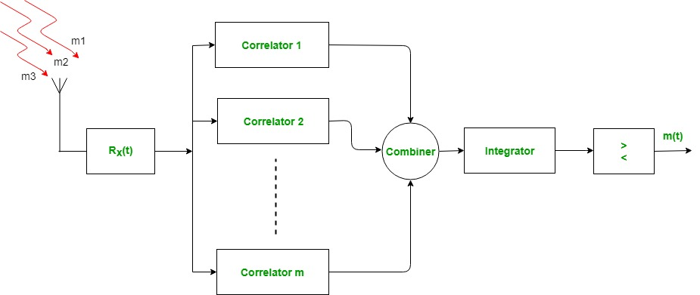

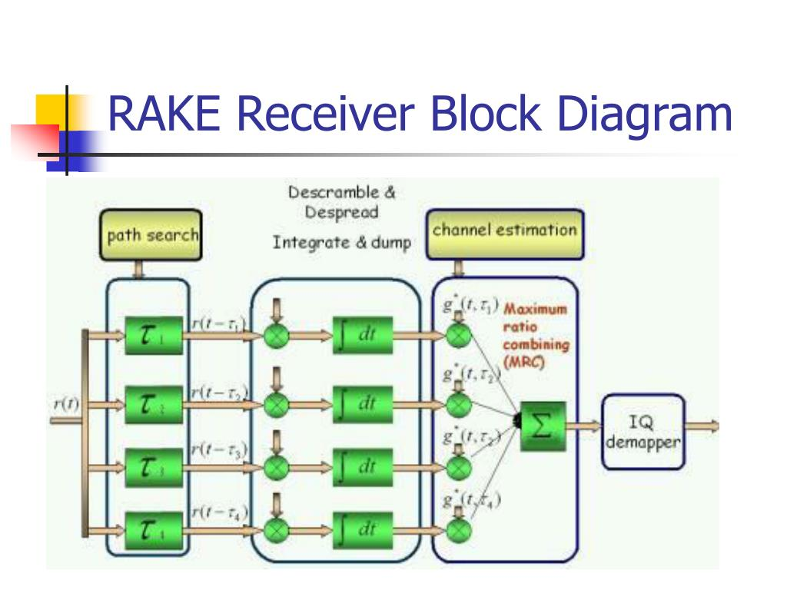

**Q6 : Explain SC-FDMA, IDMA, OFDMA schemes and hybrid method of multiple access schemes.**

**Answer :**

Wireless communication mein, **multiple access schemes** ka use hota hai to allow multiple users to communicate simultaneously on the same channel. Yahan pe SC-FDMA, IDMA, OFDMA, aur hybrid methods ke baare mein simplified explanation aur real-life examples ke saath diya gaya hai:

**1. SC-FDMA (Single Carrier Frequency Division Multiple Access):**

* **Explanation:** SC-FDMA ek single-carrier modulation technique hai jo mainly LTE uplink (user to tower) mein use hoti hai. Ye OFDMA ka ek variant hai jo PAPR (Peak-to-Average Power Ratio) kam karta hai. Ismein users ke signals ko frequency subcarriers par distribute kiya jata hai.
* **Advantage:**
  + Kam power consumption, isliye battery-efficient (important for mobile devices).
* **Example:** Jaise tumhare phone ka tower ko data bhejna during a call or video upload.

**2. IDMA (Interleave Division Multiple Access):**

* **Explanation:** Is scheme mein users ke data ko interleaving ke zariye separate kiya jata hai. Har user ka data ek unique interleaving pattern ke saath transmit hota hai, jo collision avoid karta hai.
* **Advantage:**
  + Simple implementation aur high data rate.
* **Example:** Imagine karo tumhare aur tumhare friend ke messages different shuffles ke saath bheje gaye hain; receiver ko easily identify karne mein madad milegi.

**3. OFDMA (Orthogonal Frequency Division Multiple Access):**

* **Explanation:** Ismein users ke data ko orthogonal subcarriers ke upar bheja jata hai. Ye frequency bands ko efficiently divide karta hai. Ye mainly 4G and 5G downlink (tower to user) mein use hota hai.
* **Advantage:**
  + High spectral efficiency aur interference kam hoti hai.
* **Example:** Tum YouTube stream karte ho aur tumhare neighbor Netflix, toh dono ke liye OFDMA ka alag bandwidth allocate hota hai bina clash ke.

**4. Hybrid Methods (Combination of Techniques):**

* **Explanation:** Hybrid methods multiple access schemes ko combine karte hain to achieve better performance. For example:
  + **OFDMA + SC-FDMA:** Downlink mein OFDMA aur uplink mein SC-FDMA.
  + **IDMA + OFDMA:** Better interference management.
* **Advantage:**
  + Flexibility aur efficiency dono ka balance milta hai.
* **Example:** Ek modern 5G network jo uplink aur downlink ke liye alag-alag techniques use karta hai, taaki battery-efficient aur high-speed communication dono achieve ho.

**Q7 : Differentiate among FDMA, TDMA and CDMA multiple access techniques.**

**Answer :**

FDMA, TDMA, aur CDMA teen alag-alag **multiple access techniques** hain jo wireless communication mein use hote hain. Inka kaam ek shared communication channel mein multiple users ko efficiently connect karna hai. Yahaan ek simple differentiation diya gaya hai with real-life examples:

|  |  |  |  |
| --- | --- | --- | --- |
| Feature | FDMA (Frequency Division Multiple Access) | TDMA (Time Division Multiple Access) | CDMA (Code Division Multiple Access) |
| Basis | Frequency divide karta hai | Time divide karta hai | Codes assign karta hai |
| Working | Har user ke liye ek unique frequency band allocate hota hai. | Har user ko fixed time slot assign hota hai. | Har user ek unique code ke saath signal transmit karta hai. |
| Interference | Adjacent frequency interference ka chance. | Time synchronization zaroori hai. | Low interference, lekin complex implementation. |
| Efficiency | Frequency spectrum ka effective use nahi hota. | Medium efficiency. | High spectral efficiency. |
| Example | Analog FM radio stations (e.g., 92.7 MHz, 98.3 MHz). | GSM networks for mobile calls. | CDMA-based mobile networks like older 3G systems. |
| Real-Life Analogy | Jaise alag-alag radio stations ki frequencies. | Jaise ek lift jo har user ko fixed time ke liye allow kare. | Jaise ek hall jisme log alag languages mein baat karte hain. |

**Key Points:**

1. **FDMA**: Har user ke liye ek alag frequency band reserve hota hai. Example: FM radio stations.
2. **TDMA**: Sabhi users ek frequency share karte hain, lekin unke liye alag-alag time slots assign hote hain. Example: GSM networks.
3. **CDMA**: Sabhi users ek hi frequency aur time share karte hain, lekin unique codes ki wajah se signals separate hote hain. Example: 3G networks.

**Q8 : What does Packet Reservation Multiple Access (PRMA) mean?**

**Answer :**

**Packet Reservation Multiple Access (PRMA)** ek multiple access protocol hai jo wireless communication mein use hota hai, mainly voice aur data traffic ke liye. Ye TDMA (Time Division Multiple Access) aur packet-switching techniques ka combination hai.

**Explanation:**

1. **Dynamic Slot Allocation:**  
   PRMA mein ek shared time frame ko multiple time slots mein divide kiya jata hai. Voice aur data packets in slots ka use karte hain.
2. **Reservation Mechanism:**
   * Jab koi user data bhejna start karta hai, toh wo ek time slot ko "reserve" kar leta hai.
   * Reservation tab tak rehti hai jab tak user data bhej raha ho. Agar user inactive ho jaye, toh slot free ho jata hai aur dusre user ke liye available ho jata hai.
3. **Efficiency:**  
   Ye protocol bandwidth ko efficiently allocate karta hai, especially jab users ke beech data traffic irregular ho.

**Real-Life Example:**

* Socho ek conference call ho raha hai:
  + Jab koi participant bol raha hai (active user), unke liye slot reserve ho jata hai.
  + Jab participant chup ho jaye (inactive user), toh slot dusre participant ke liye free ho jata hai.

**Advantages:**

1. Bandwidth ka efficient use hota hai.
2. Voice aur data traffic ke liye suitable hai.
3. Inactive users ke slots waste nahi hote.

**Q9 : Draw the block diagram of Equalization survey and explain different Equalization techniques used in Wireless Communication.**

**Answer :**

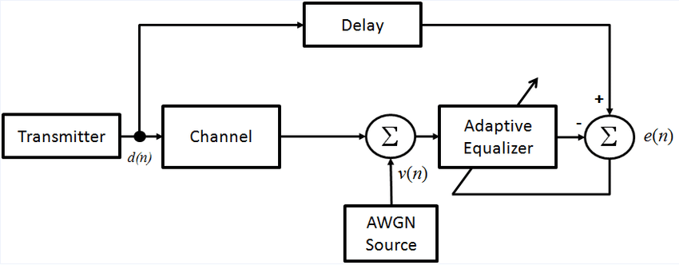

Yahaan Equalization process ka block diagram diya gaya hai. Ab main different **Equalization techniques** ko explain karta hoon:

**Equalization Techniques:**

1. **Linear Equalizer:**
   * **Working:** Ismein input signal ko filter karke distortion ko kam kiya jata hai. Ye fixed weights ka use karta hai.
   * **Advantage:** Simple to implement.
   * **Limitation:** Strong noise aur interference ke against effective nahi hota.
   * **Example:** FIR (Finite Impulse Response) filter.
2. **Decision Feedback Equalizer (DFE):**
   * **Working:** Ismein ek feedback loop use hota hai jo pehle detect kiye gaye signals ka use karke errors ko correct karta hai.
   * **Advantage:** Better performance in multipath environments.
   * **Limitation:** Complexity zyada hoti hai.
3. **Adaptive Equalizer:**
   * **Working:** Ye real-time mein apne parameters adjust karta hai based on the incoming signal aur channel conditions.
   * **Advantage:** Changing environments mein effective hai.
   * **Limitation:** High computational complexity.

**Real-Life Example:**

* Imagine karo tumhari car FM radio signal distort hone lage jab tum ek tunnel se guzarte ho. Equalizers signal ko adjust karke audio ko clear banate hain.

**Unit : 5**

**Q10 : Explain the 4G system and its applications.**

4G refers to the fourth generation of mobile network technology, succeeding 3G (Third Generation) networks. It represents a significant advancement in wireless communication, offering faster speeds, better performance, and enhanced capabilities compared to its predecessors.

**Key Features of 4G:**

1. **High-Speed Data:** 4G networks are designed to provide significantly faster data speeds compared to 3G. They aim for peak download speeds of up to 100 Mbps and upload speeds of up to 50 Mbps.
2. **Low Latency:** 4G networks reduce latency, allowing quicker response times, which is crucial for real-time applications like video calls, online gaming, and live streaming.
3. **IP-Based Technology:** 4G is based on an all-IP (Internet Protocol) network architecture, facilitating seamless integration with other IP-based services and applications.
4. **Improved Efficiency:** It optimizes the use of radio spectrum, allowing more efficient data transmission and handling more users simultaneously.
5. **Enhanced Multimedia Support:** 4G networks provide better support for high-definition video streaming, multimedia applications, and rich content services due to their higher data rates.

**Q11 : What do you understand by mobile Ad-Hoc network (MANETs)? Why and how a proper route is required to discover in Ad-Hoc network?**

**Mobile Ad-Hoc Networks (MANETs):**

**Definition:**

Mobile Ad-Hoc Networks (MANETs) ek self-configuring network hote hain jisme mobile devices (jese smartphones, laptops, etc.) bina kisi fixed infrastructure (jese router ya base station) ke directly ek dusre se communicate karte hain.

**Key Characteristics of MANETs:**

1. **Infrastructure-less**: Koi fixed base station nahi hota, devices hi network ko form aur manage karte hain.
2. **Dynamic Topology**: Devices move karte hain, isliye network ka structure (topology) bar-bar change hota hai.
3. **Multi-hop Communication**: Ek device directly data nahi bhej paati, to intermediate devices ka use hota hai (multi-hop routing).
4. **Decentralized**: Central control system nahi hota, har device ka equal role hota hai.

**Real-Life Example:**

Socho ek disaster area hai jaha mobile towers damage ho gaye hain. Rescuers apne devices ke through ek temporary network create karte hain to communicate. Ye MANET ka ek example hai.

**Why Proper Route Discovery is Required in MANETs?**

**Challenges in MANETs:**

1. **Dynamic Topology**: Devices move karte rehte hain, isliye routes stable nahi hote.
2. **Limited Resources**: Devices ke paas limited battery aur bandwidth hoti hai.
3. **Interference**: Multiple devices ke signals interfere karte hain, jo communication ko slow ya unreliable bana dete hain.

**Need for Proper Route Discovery:**

1. **Efficient Communication**: Data packets ko shortest aur least congested path ke through bhejna.
2. **Reduced Energy Consumption**: Agar route efficient hoga, to devices ki battery kam use hogi.
3. **Minimized Packet Loss**: Accurate routing se data packets destination tak bina loss ke pahuchte hain.
4. **Scalability**: Network bade hone par bhi performance maintain karna.

**How Route Discovery Works in MANETs?**

**Common Routing Protocols in MANETs:**

1. **Proactive Routing (e.g., DSDV - Destination-Sequenced Distance Vector):**
   * **How it Works:**
     + Pre-defined routing tables har node ke paas hoti hain.
     + Routes continuously update hote hain, chahe data bhejna ho ya nahi.
   * **Advantage:** Fast communication (no delay).
   * **Disadvantage:** High resource consumption due to constant updates.
2. **Reactive Routing (e.g., AODV - Ad-hoc On-demand Distance Vector):**
   * **How it Works:**
     + Route tabhi discover hota hai jab data transmission ki zarurat hoti hai.
     + Route request (RREQ) messages bheje jaate hain aur responses (RREP) ke through path establish hota hai.
   * **Advantage:** Resource-efficient.
   * **Disadvantage:** Initial delay in communication.
3. **Hybrid Routing (e.g., ZRP - Zone Routing Protocol):**
   * **Combination of proactive and reactive routing**.
   * Near nodes ke liye proactive routing aur far nodes ke liye reactive routing use hota hai.

**Example of Route Discovery in Reactive Routing (AODV):**

1. **Route Request (RREQ):**
   * Source node ek broadcast message bhejta hai jo sab nearby nodes ko route request karta hai.
2. **Route Reply (RREP):**
   * Destination node ya koi intermediate node jisko route pata hai, ek reply message bhejta hai.
3. **Path Establishment:**
   * Best route choose karke data packets send hote hain.

**Q12 : Discuss a complete model of Next Generation Network system for mobile communication. How it is useful for network security?**

**Next Generation Network (NGN) System for Mobile Communication**

**Definition of NGN:**

Next Generation Network (NGN) ek advanced communication system hai jo **voice, data, video, and multimedia services** ko ek integrated platform par provide karta hai. Ye system IP-based architecture ka use karta hai aur zyada flexible, efficient, aur secure communication ke liye design kiya gaya hai.

**Complete Model of NGN System**

**1. Core Components of NGN:**

1. **Access Layer**:
   * Ye layer alag-alag access technologies ko support karti hai, jaise:
     + 4G/5G cellular networks
     + Wi-Fi, Bluetooth
     + Fiber-optic or DSL networks
2. **Transport Layer**:
   * Is layer me **IP-based backbone network** hota hai jo data packets ko efficiently route karta hai.
   * QoS (Quality of Service) ensure karta hai, taki voice/video calls aur data transmission me latency na ho.
3. **Control Layer**:
   * Ye layer signaling aur session management ke liye responsible hai.
   * Examples: SIP (Session Initiation Protocol), H.323 protocols.
4. **Service Layer**:
   * Ye layer **user applications aur multimedia services** provide karti hai, jaise:
     + VoIP (Voice over IP)
     + Video Conferencing
     + Cloud services
5. **Application Layer**:
   * Is layer me end-user applications aur services hoti hain, jo NGN platform ke upar run karti hain.
   * Examples: Social media apps, enterprise apps, IoT systems.

**How NGN is Useful for Network Security?**

NGN systems modern security features integrate karte hain jo traditional networks me nahi hote. Ye kuch tarike hain jinse NGN network security me madad karta hai:

**1. IP-based Security:**

* NGN ka IP-based architecture **encryption techniques (e.g., SSL/TLS)** ka use karta hai to data ko secure karne ke liye.

**2. Authentication and Authorization:**

* NGN systems me har user aur device ka **authentication** hota hai, taki unauthorized access prevent kiya ja sake.

**3. Network Address Translation (NAT):**

* NGN me NAT use hota hai jo private IP addresses ko hide karta hai aur external threats se network ko protect karta hai.

**4. Firewall and Intrusion Detection Systems (IDS):**

* Firewalls malicious traffic ko block karte hain, aur IDS suspicious activity ko detect karke alert generate karta hai.

**5. Virtual Private Networks (VPNs):**

* NGN me VPN ka use hota hai secure remote access ke liye.

**6. Secure Routing Protocols:**

* NGN me routing protocols (e.g., OSPF, BGP) ko tampering-proof banaya gaya hai, jisse secure data transmission ensure hoti hai.

**7. Resilience Against DDoS Attacks:**

* NGN systems DDoS attacks ko handle karne ke liye **load balancing** aur **traffic filtering** techniques use karte hain.

**Real-World Applications of NGN:**

1. **5G Networks**: High-speed internet aur IoT devices ke liye.
2. **Smart Cities**: Energy management, traffic control, and surveillance systems.
3. **Enterprise Solutions**: Cloud-based VoIP aur secure video conferencing systems.
4. **Healthcare**: Telemedicine aur remote patient monitoring.

**Advantages of NGN for Security:**

1. **Integrated Security**: NGN architecture me built-in security features hote hain, jisse alag se security layers lagane ki zarurat nahi hoti.
2. **Scalability**: NGN dynamic hai, jisse naye devices aur users ko securely integrate kiya ja sakta hai.
3. **End-to-End Protection**: NGN end-to-end encryption aur monitoring ensure karta hai.
4. **Rapid Threat Detection**: Advanced analytics aur AI-based monitoring systems threats ko jaldi detect aur mitigate karte hain.

**Conclusion:**

NGN ek robust aur secure communication model hai jo modern mobile communication systems ke liye essential hai. Iska IP-based design flexibility aur efficiency provide karta hai, aur advanced security features network vulnerabilities ko minimize karte hain.

**Q13 : Draw the architecture of GSM and explain each block.**

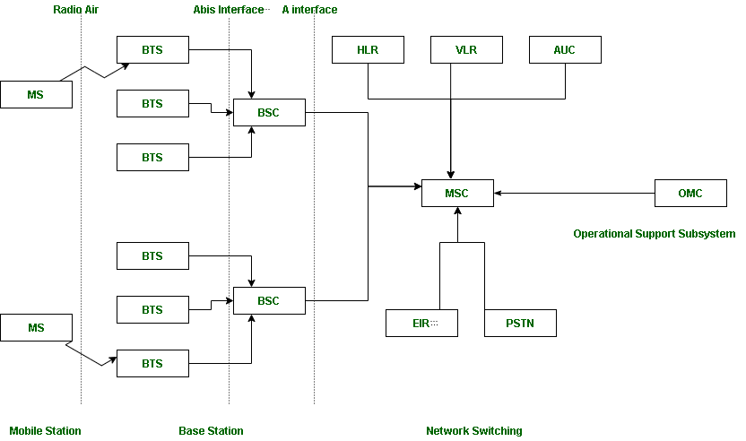

**Architecture of GSM (Global System for Mobile Communication):**

GSM ek widely used standard hai for mobile communication. Iska architecture modular aur hierarchical hota hai, jo efficient communication aur management ensure karta hai. GSM ke main components niche diye gaye hain:

**Explanation of Each Block:**

**1. Mobile Station (MS):**

* **Definition**: User ke paas jo mobile device hota hai, wo MS kehlata hai.
* **Components**:
  + **Mobile Equipment (ME)**: Actual handset device jo communication karta hai.
  + **Subscriber Identity Module (SIM)**: Secure card jo user ki identity aur subscription details store karta hai.
* **Functions**:
  + Voice, data, SMS send/receive karta hai.
  + Authentication aur encryption ke liye SIM ka use karta hai.

**2. Base Station Subsystem (BSS):**

* **Definition**: Ye subsystem wireless communication ko manage karta hai mobile devices aur network ke beech.
* **Components**:
  + **Base Transceiver Station (BTS)**:
    - Radio antennas hote hain jo mobile devices ke saath wireless communication karte hain.
    - Ek BTS ek specific area (cell) ko cover karta hai.
  + **Base Station Controller (BSC)**:
    - Multiple BTS ko control karta hai.
    - Call setup, handovers, aur power control manage karta hai.

**3. Network Switching Subsystem (NSS):**

* **Definition**: Core network jo call switching, mobility management, aur database management ke liye responsible hai.
* **Components**:
  + **Mobile Switching Center (MSC)**:
    - Call setup, routing, aur switching handle karta hai.
    - Public networks (PSTN, ISDN) ke saath connection establish karta hai.
  + **Home Location Register (HLR)**:
    - Permanent database jo subscriber ki details (phone number, plan, location) store karta hai.
  + **Visitor Location Register (VLR)**:
    - Temporary database jo roaming users ki location aur authentication details store karta hai.
  + **Authentication Center (AUC)**:
    - User authentication aur data encryption ke liye keys provide karta hai.
  + **Equipment Identity Register (EIR)**:
    - Blacklisted mobile devices ko detect aur block karta hai.

**4. External Networks:**

* **Definition**: GSM system ka connection external communication networks ke saath hota hai.
* **Types of Networks**:
  + **PSTN (Public Switched Telephone Network)**: Landline networks ke saath connection.
  + **ISDN (Integrated Services Digital Network)**: Digital communication system.
  + **PDN (Public Data Network)**: Internet aur packet-switched data networks.

**Key Features of GSM Architecture:**

1. **Hierarchical Design**: Communication efficient aur scalable hota hai.
2. **Roaming Support**: Global mobility management ke liye HLR/VLR databases ka use hota hai.
3. **Security**: Authentication aur encryption ke through secure communication provide karta hai.

**Real-Life Example:**

Jab ek mobile user kisi aur city me travel karta hai (roaming), to VLR uski temporary details store karta hai. Roaming ke time calls MSC ke through route hoti hain aur HLR se authentication li jaati hai.

**Q14 : Explain CDMA 2000.**

**CDMA2000: An Overview**

**CDMA2000** ek advanced mobile communication standard hai jo **Code Division Multiple Access (CDMA)** technology par based hai. Ye 3G mobile networks ka ek popular variant hai jo voice, data, aur multimedia services ko efficiently support karta hai.

**Key Features of CDMA2000:**

1. **High Data Rates**:
   * Offers data rates up to **3.1 Mbps** for download and **1.8 Mbps** for upload.
2. **Backward Compatibility**:
   * Compatible with CDMAOne (2G technology).
3. **Multi-Carrier Support**:
   * Allows multiple carriers to transmit data simultaneously.
4. **Enhanced QoS**:
   * Provides excellent **Quality of Service (QoS)** for voice and data.
5. **Spectrum Efficiency**:
   * Efficient use of spectrum by spreading signals across wide bandwidth.

**Architecture of CDMA2000:**

1. **Mobile Station (MS):**
   * Devices like smartphones and data terminals used by end-users.
2. **Base Station Subsystem (BSS):**
   * Contains Base Transceiver Station (BTS) and Base Station Controller (BSC) to handle wireless communication.
3. **Packet Core Network:**
   * Manages IP-based data services like internet access and multimedia.
4. **Circuit Core Network:**
   * Handles traditional voice calls.
5. **Authentication and Security Systems:**
   * Ensures secure communication through encryption and authentication protocols.

**Working of CDMA2000:**

1. **Spreading Code**:
   * Each user’s signal is multiplied by a unique spreading code to distinguish it from others.
2. **Wideband Transmission**:
   * The signal is transmitted over a wide frequency range, reducing interference.
3. **Base Station Reception**:
   * At the base station, the same unique spreading code is used to extract the user’s original signal.
4. **Multi-Carrier Communication**:
   * Data is transmitted over multiple carriers for better speed and reliability.

**Variants of CDMA2000:**

1. **CDMA2000 1X (1xRTT):**
   * Supports up to **153 Kbps** data rates. Used for voice and basic data services.
2. **CDMA2000 1xEV-DO (Evolution Data Optimized):**
   * High-speed data services with download rates up to **3.1 Mbps**.
   * Primarily used for internet access and multimedia.
3. **CDMA2000 1xEV-DV (Evolution Data and Voice):**
   * Combines high-speed data and voice services on the same channel.

**Advantages of CDMA2000:**

1. **High Capacity**: Supports more users per MHz of bandwidth compared to GSM-based systems.
2. **Efficient Handoffs**: Soft handoffs improve call reliability during mobility.
3. **High Data Rates**: Ideal for video streaming, internet browsing, and multimedia applications.
4. **Global Roaming**: Widely used in North America and parts of Asia.

**Applications of CDMA2000:**

1. **Mobile Broadband**: High-speed internet access.
2. **Video Streaming**: Supports multimedia streaming applications.
3. **VoIP Services**: Voice over IP calls with enhanced quality.
4. **IoT Devices**: Used in IoT solutions requiring reliable and efficient communication.

**Real-Life Example:**

Socho tum kisi city ke crowded area me ho jaha multiple users apne phones par voice calls aur internet use kar rahe hain. CDMA2000 efficiently sabka data transmit karta hai bina interference ke, kyunki har user ka unique spreading code hota hai.

**Q15 : What are the main characteristics of IMT-2000?**

**Main Characteristics of IMT-2000**

**IMT-2000** (International Mobile Telecommunications-2000) ek ITU (International Telecommunication Union) ka framework hai jo **3G (Third Generation)** mobile communication standards define karta hai. Ye framework high-speed wireless communication aur global roaming ensure karta hai.

**Key Characteristics of IMT-2000:**

**1. High Data Rates**

* **Voice Communication**: Up to **144 Kbps** for mobile users in vehicles.
* **Stationary Users**: Up to **2 Mbps** in stationary or indoor environments.
* **Broadband Capability**: Enhanced for internet browsing, video conferencing, and multimedia streaming.

**2. Global Roaming**

* Ek unified system jo users ko globally roam karne deta hai across different networks.
* Compatible with GSM, CDMA, and other mobile standards.

**3. Multiple Access Techniques**

* Supports various access methods like **CDMA, TDMA, and FDMA**, making it flexible for diverse implementations.

**4. Spectrum Efficiency**

* Efficient use of frequency spectrum, enabling more users to connect within a limited bandwidth.

**5. Compatibility with Previous Technologies**

* Backward compatibility with **2G technologies** (GSM, IS-95) for smooth transition.

**6. Multiservice Capability**

* Provides diverse services like:
  + Voice calls
  + SMS
  + High-speed internet
  + Multimedia applications (video conferencing, streaming).

**7. Seamless Handoffs**

* Ensures uninterrupted communication during mobility, even across different network technologies.

**8. Support for Packet and Circuit Switching**

* Uses **packet-switched technology** for data services and **circuit-switched technology** for voice.

**9. Quality of Service (QoS)**

* Guarantees high QoS for multimedia applications, reducing latency and improving reliability.

**10. Support for Wide Coverage Areas**

* Suitable for urban, rural, and remote areas with varying user densities.

**Real-Life Example of IMT-2000 Features**

* Jab tum ek high-speed train me travel kar rahe ho aur tumhare phone par video call chal rahi ho, IMT-2000 ki **high data rate aur seamless handoff** features ensure karte hain ki call stable rahe.

**Importance of IMT-2000**

1. **Global Standardization**: Ek unified framework jo mobile networks ko globally compatible banata hai.
2. **Enhanced User Experience**: High-speed data aur reliable communication offer karta hai.
3. **Foundation for Future Technologies**: IMT-2000 ne 4G aur 5G technologies ke liye ek base prepare kiya.